Last Updated on 08/02/2020

Dear friend:

I am enclosing my résumé for you to consider the next time you have a need for a passionate and talented actor or director who is going to give your project all that he has got! You should always choose the right talent who best suits your needs, even if that person is not me.

With that said, I would be honored if you chose to interview me or have me audition for a role in your production. Ask me your toughest questions so you are confident in my abilities. I want to earn your respect by showcasing my talents and what I bring to the table. It is important to make sure my skills are the right match for your specific message and portraying the situation as realistically as possible on camera or on stage. I have been an actor since the day I was born in 1985, with extensive experience in both theater and on film from a young age throughout this page I have posted some of my credits and reels show casing my work.

My dedication to my Youtube Channel and honing my art to provide the best results possible means that I always work to exceed my own expectations. If you choose me as your lead actor or director, I promise that I will strive to be the best talent with whom you have ever worked!

With gratitude,

Mansur Haq
Actor / Director
ZRE Productions®
(818) 850-5310
Mansur.A.Haq@gmail.com
www.MansurHaq.com

 | Mansur Haq  Actor – Director  (818) 850-5310  Mansur.A.Haq@gmail.com  www.MansurHaq.com | 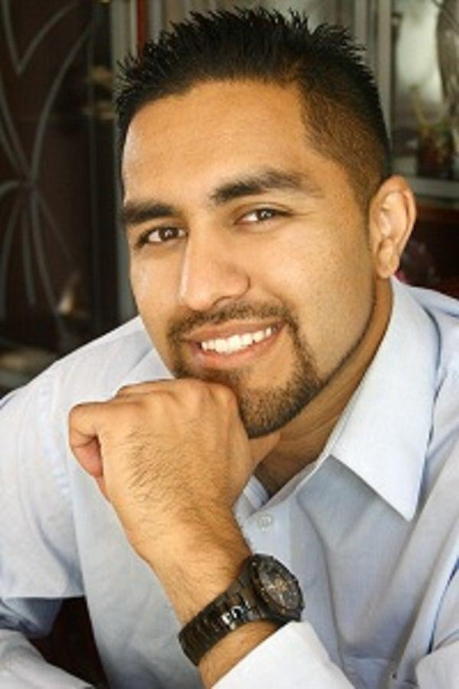

SUMMARY
In-depth knowledge and understanding of the art of performing and directing film and stage productions. Talented at working with people from diverse communities and backgrounds. Based out of the Northern California region but will consider traveling for projects world-wide. Personal approach towards projects based on relationships and career growth, not money or transactions. Focused and diligent approach to understanding each producer’s goals and to meet needs leveraging years of experience being an actor. Reputation as a trusted artist and advisor for many of his peers with honest communication and ability to bring out the best in fellow artists effectively coaching them to bring out their best performance to the table. Diverse experience and interpersonal skills to establish and maintain rapport with fellow artists and producers from all types of backgrounds on all types of projects.

QUALIFICATIONS
- Experienced Actor/Director with multiple types of large and small projects on resume and reel credits.
- Well connected within the performing arts scene in the Greater San Francisco Bay Area and Sacramento Area
- Familiarity with working with First Time Producers, Experienced Talent, Large scale and Micro-budget Projects.
- Excellent interpersonal skills; strong director, producer and artist focused service which can deliver results
- Skilled at building effective and productive relationships aimed at retaining present business and creating new business opportunities for both myself and my fellow peers.

EXPERIENCE
July 2020 | Red Corner Audition, Coach Alonzo  Moorevision Production Film, filmed in Richmond, CA  - This was an audition which was filmed during the shelter-in-place COVID-19 restrictions and uploaded to YouTube.
March 2020 | Satan’s Visit to his Psychiatrist, Dr.Malcolm Saheeb  Getting Teens Saved Productions, Filmed in Sacramento, CA  - I direct and am featured as portraying Dr. Malcolm Saheeb in this production.  - This was a teaser scene for a gospel play and full stage production.
January 2020 | Andreas Fault, Homicide Detective  Misty River Films Production, Filmed in Hayward, CA  - I portray a homicide detective who plays a pivotal role in the story, specifically the ending scene.
December 2019 | Bluescape Software Commercial, Executive working from home  Atomic D Productions, Filmed in San Mateo County, CA  - I portrayed a senior executive working from home on his laptop- this commercial aired on cable networks (CNN, Fox, CNBC, and other channels), in addition was used on the company’s YouTube channel and the company's websites/marketing materials.
June 2018 | Mansur Zahir Real Estate TV, , Host (Portraying myself as Real Estate Broker)  - I showcase various properties throughout California and feature some of my clients searching for a home as well.  - Tour numerous listings, open houses, and new home communities.

EDUCATION
2008 – 2010 | California State University, Sacramento  Master’s in Business Administration
2003 – 2007 | University of California, Davis  Bachelor of Science, Biotechnology

LANGUAGES
- Native Language English
- Fluent in English, Urdu, Hindi, Punjabi
- Proficient in Spanish

MEMBERSHIPS
- Member/Former Student, Contra Costa Community College, Dramatic Arts
- Member/Former Student, De Anza High School Performing Arts
- Member, Backstage®

